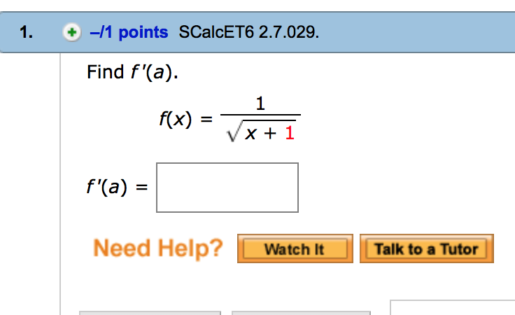
$\frac{dF^{'}\left(X\right)}{dx}=\frac{-1}{2(X+1)^3/2}$

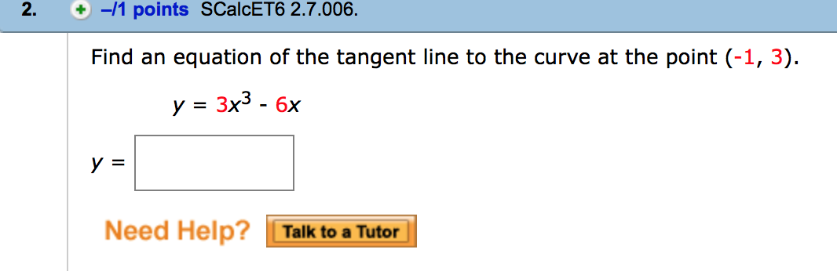
$Y=3X+6$
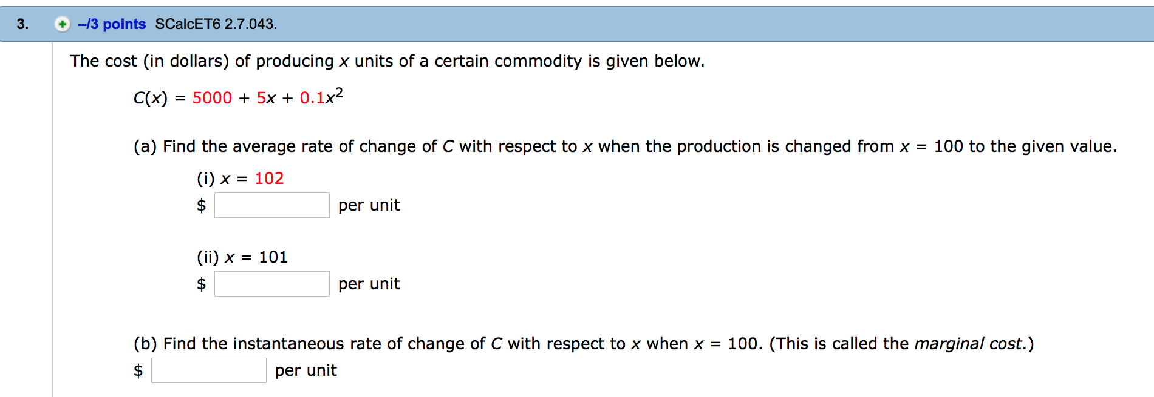
3(a) (i)=6,550.40 per unit
3(a)(ii)=65251.10 per unit
3(b) 25 per unit

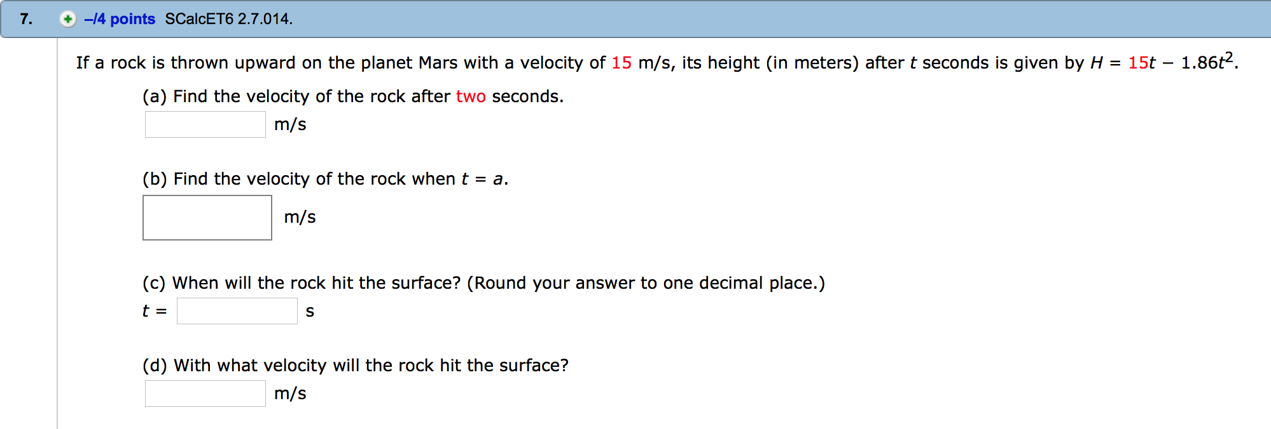
7(a)= 7.56m/s
7(b)=(15-3.72a)m/s
7(c)= 8.1 sec
7(d)= 30 m/s

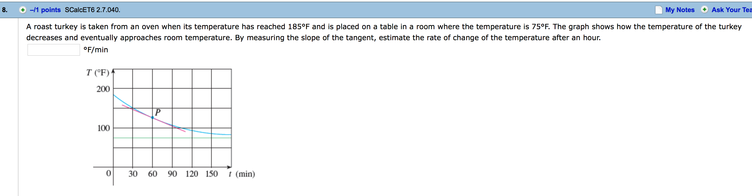
=1.08⁰f/min
Or 0.625⁰f/min
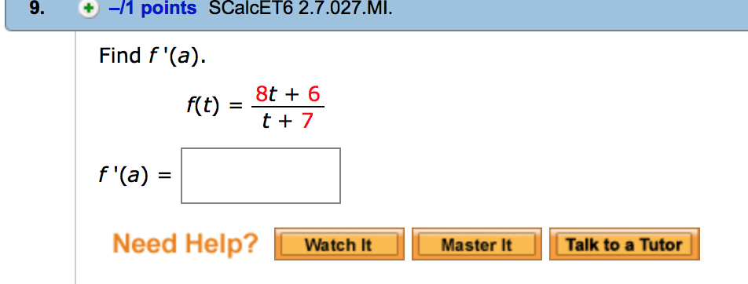

F’(a) $\frac{∂y}{∂x}=\frac{50}{{\left(t+7\right)}^{2} }$
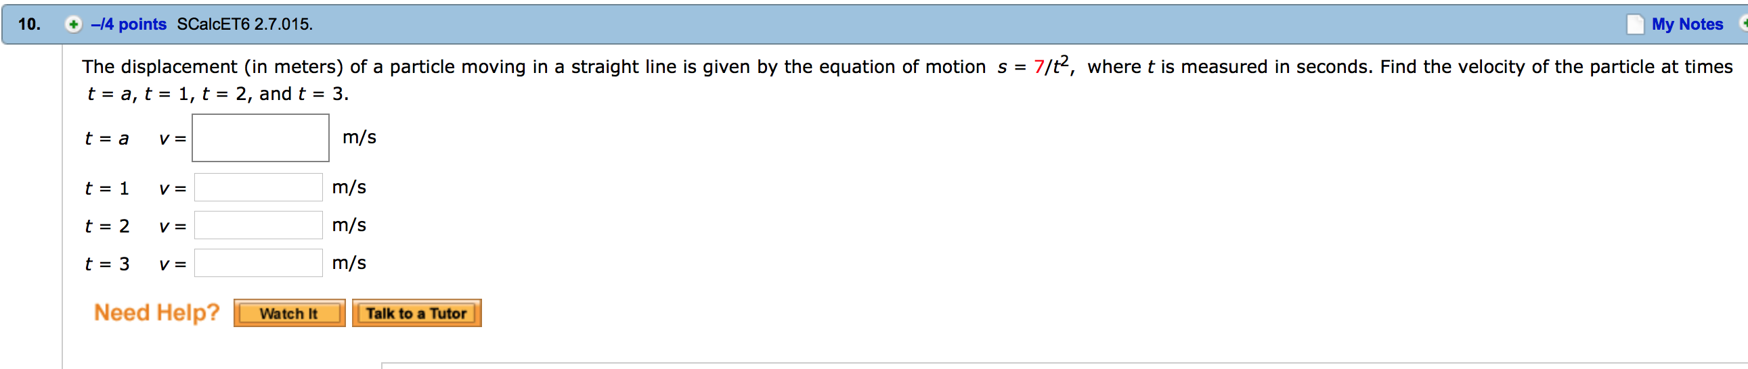
10(t=a) V= $\frac{-14}{a^{3}}$ m/s
10(t=1) V= -14m/s
10(t=2)V= -1.75m/s
10(t=3)V= $\frac{-14}{27}$m/s

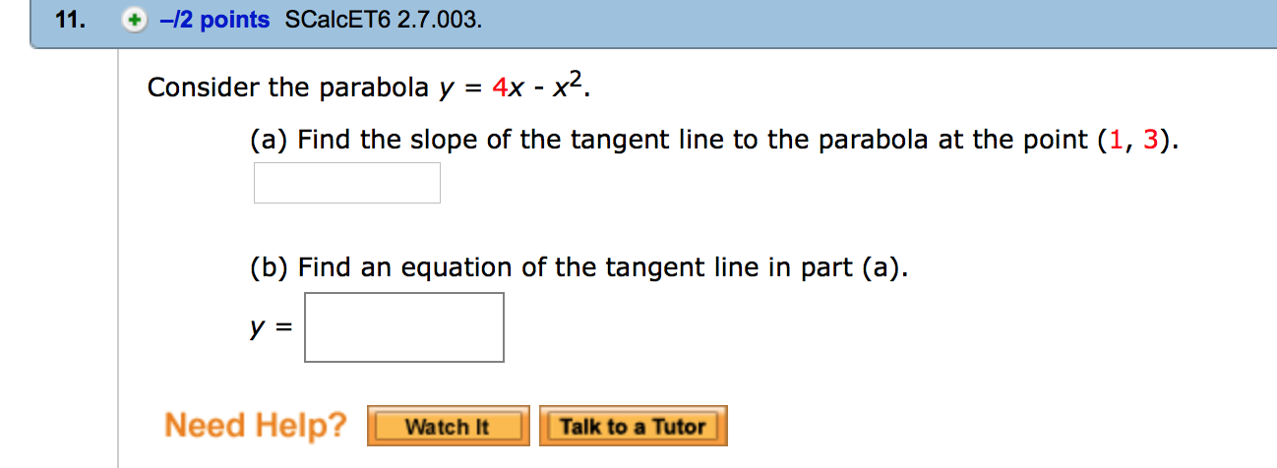
11(a)= 2
11(b) Y=2X+1
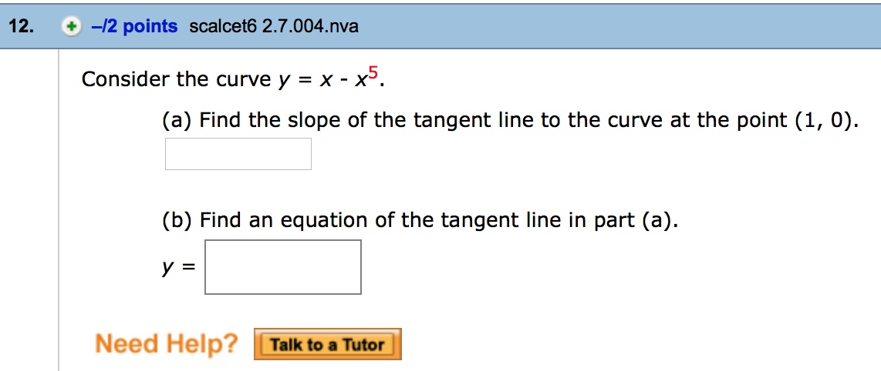
12 (A)= -4
12(B) Y=-4x+4

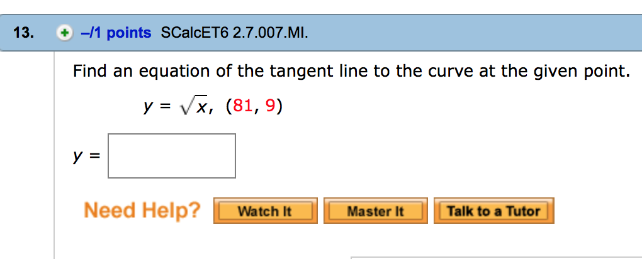
13. $Y=\frac{1}{18}x+4.5$

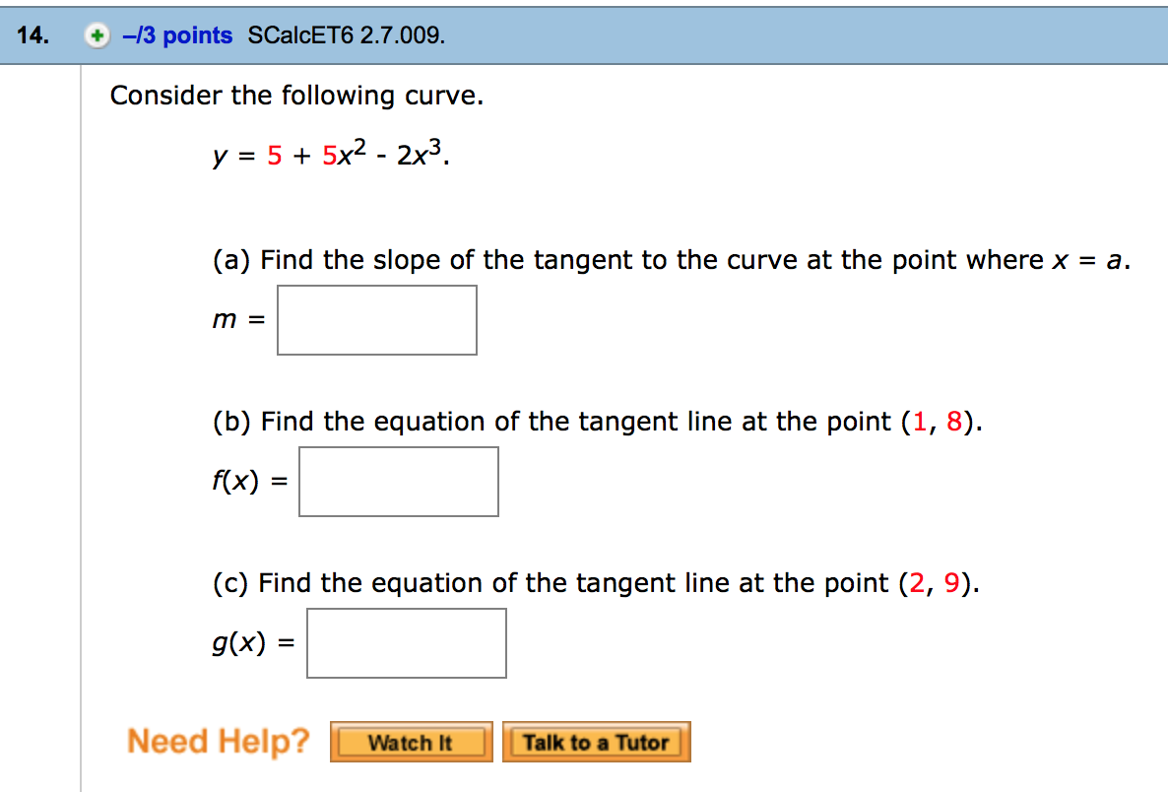
14(a) =-12
14(b) Y=4x+4
14(c) =Y=-4x+17

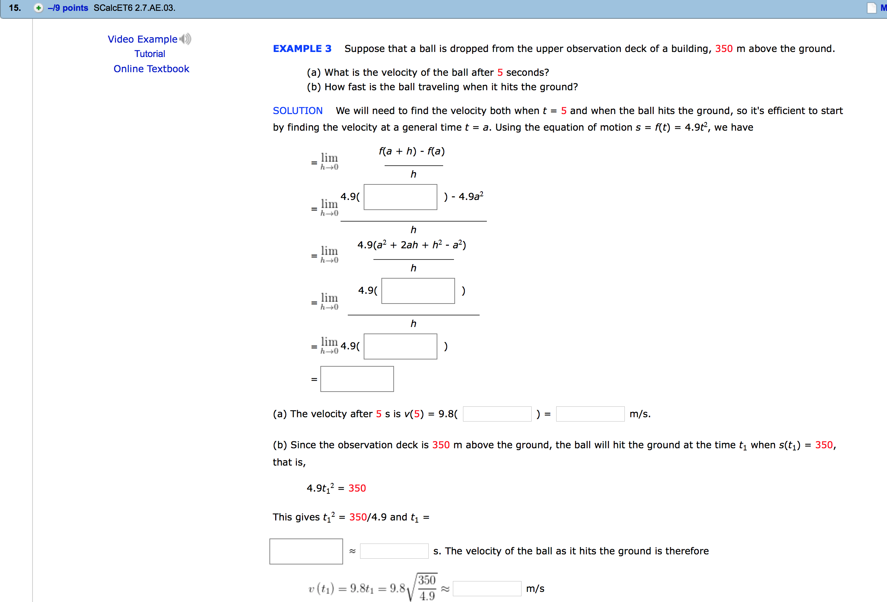
15(a), velocity after 5seconds= 245M/S
15(b), t₂=8.45 seconds
15(c) velocity at the ground=82.8 m/s
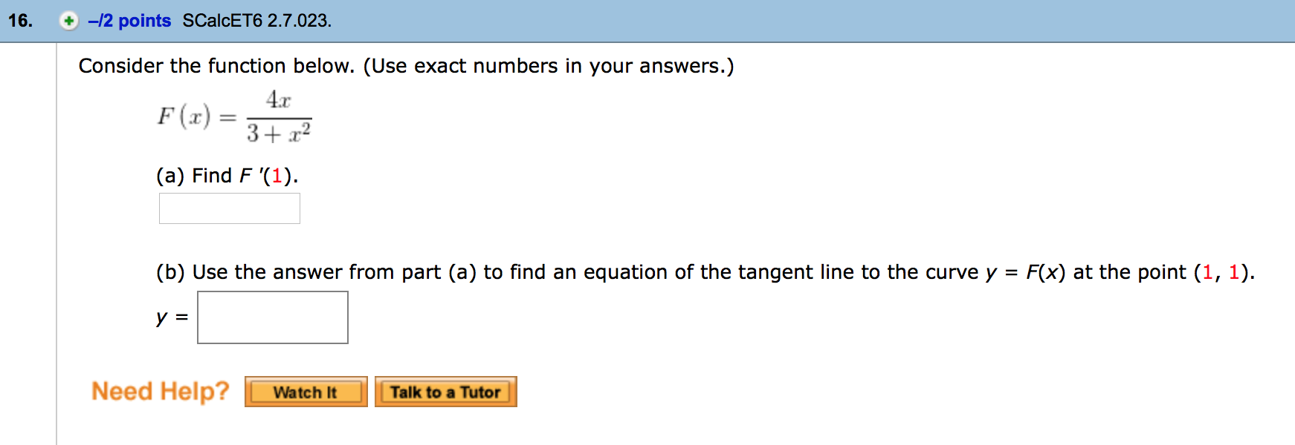
16(a) = $\frac{1}{2}$
16(b), $Y=\frac{1}{2}X+\frac{1}{2}$

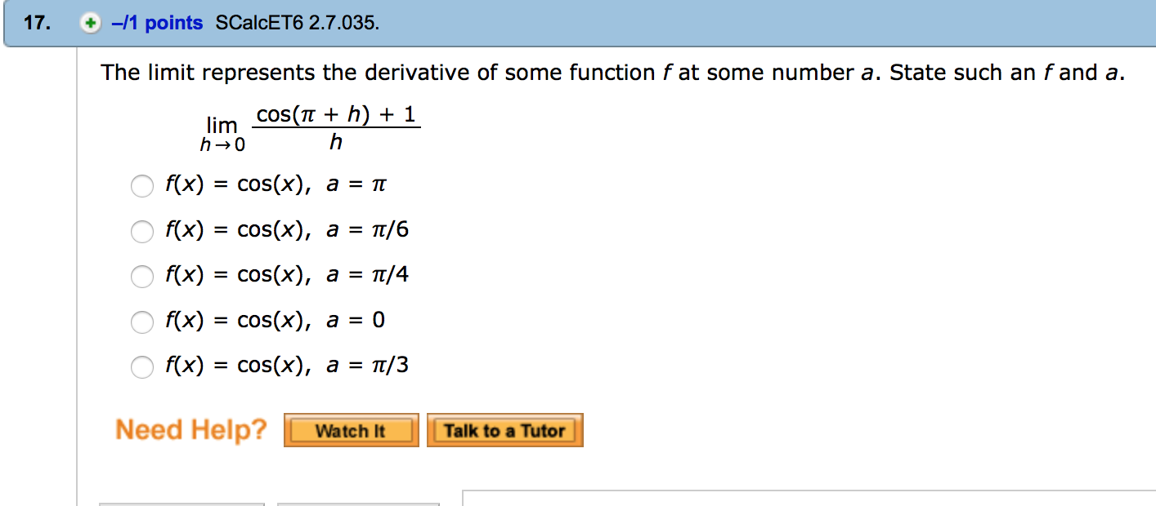
17. f’(x)=cos(x), a=0

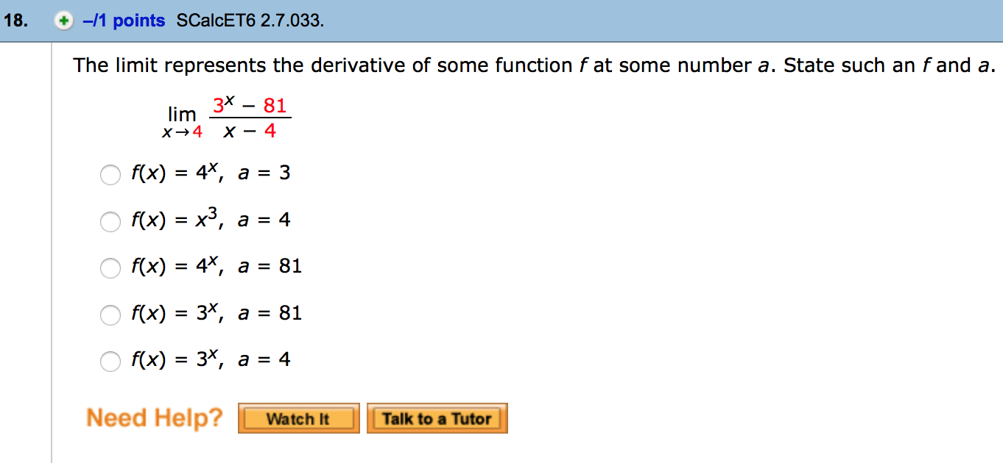
18. f’(x)= 3^{x}, a=4
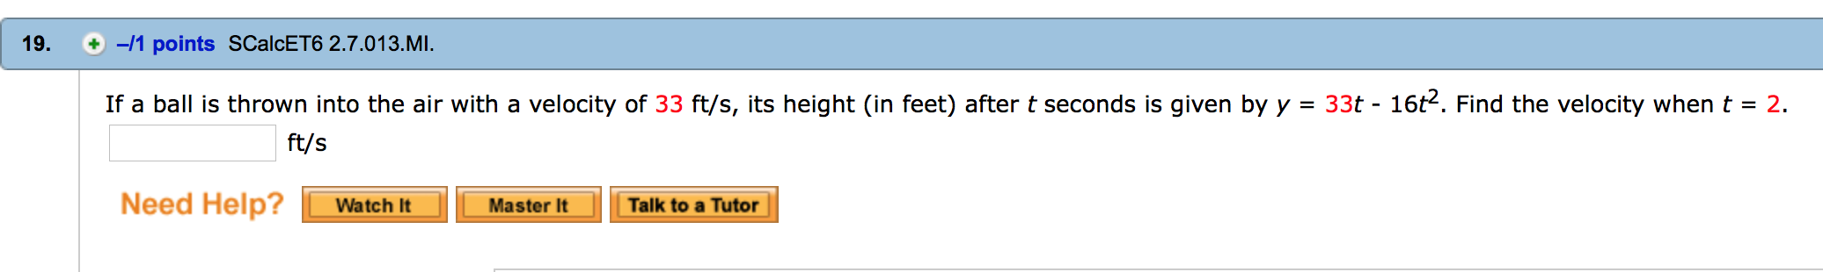
19. 2ft/s

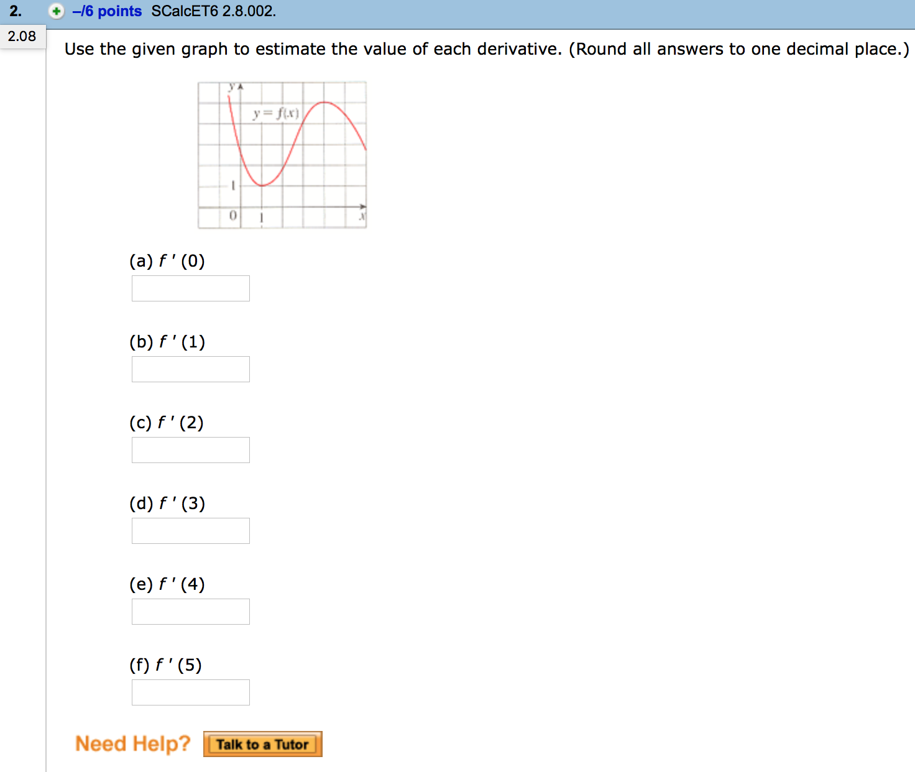
2 (a)=-2
2(b)=0
2(c)=-2
2(d)=2
2(e)=0
2(f)=-1
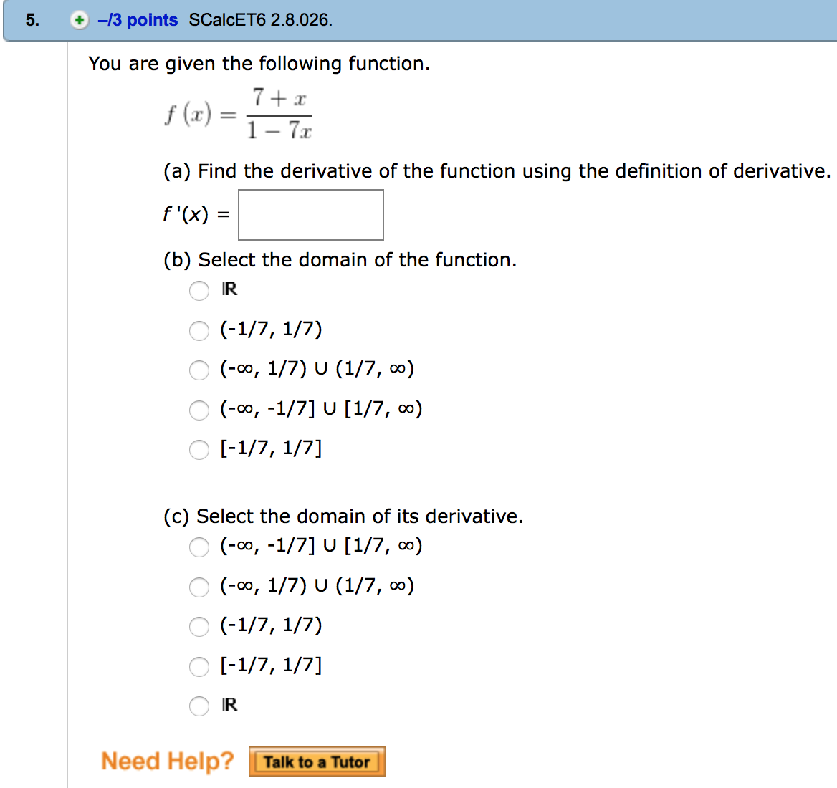
5(a)= $\frac{50}{{\left(1+7x\right)}^{2}}$
5(b)=$(-∞,-\frac{1}{7})∪(1/7,∞$)
5(c)=$(-∞,\frac{1}{7})∪(\frac{1}{7},∞)$

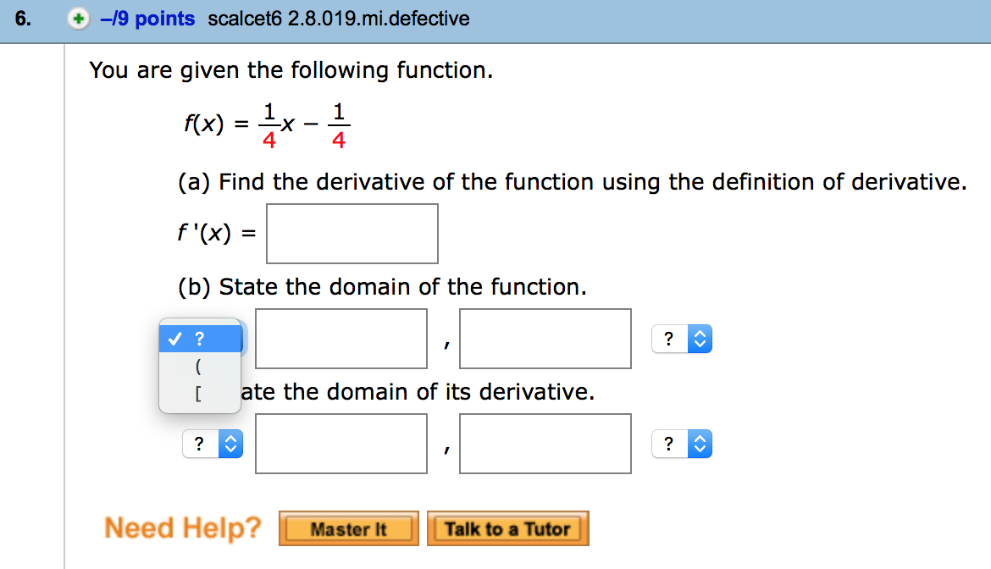
6(a)=1/4
6(b)=$(0,∞infinity$)
6(c)=$(0,∞infinity$)

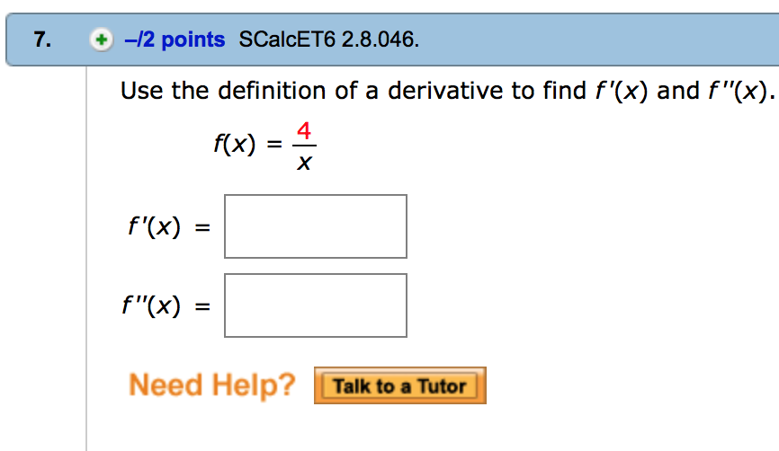
7. f’(x)=$\frac{∂`y}{∂x}=\frac{-4}{x^2}$
F’’(x)=$\frac{∂``y}{∂x}=\frac{8}{x^3}$
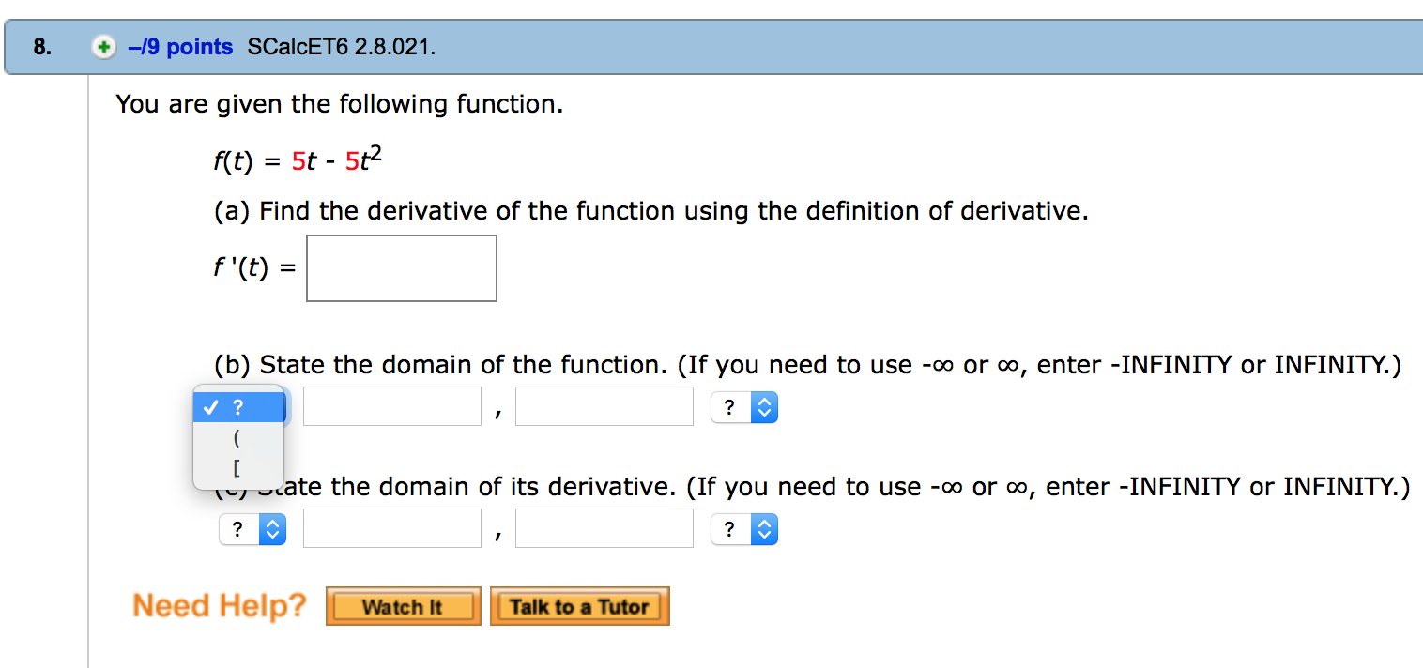
8(a)=$\frac{∂`y}{∂x}=-10t+5$
8(b)= (-infinity, infinity)
8(c)= (-infinity, infinity)
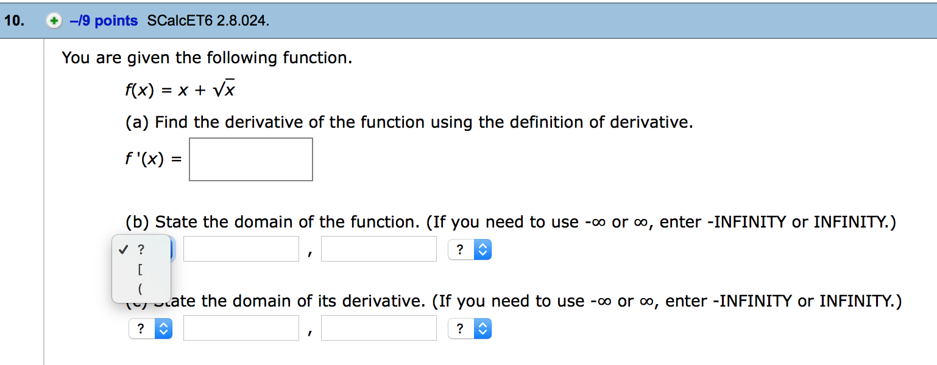
10(a)=$\frac{∂`y}{∂x}=1+\frac{1}{2√2}$
10(b) (0, infinity)
10(c)= (0, infinity)
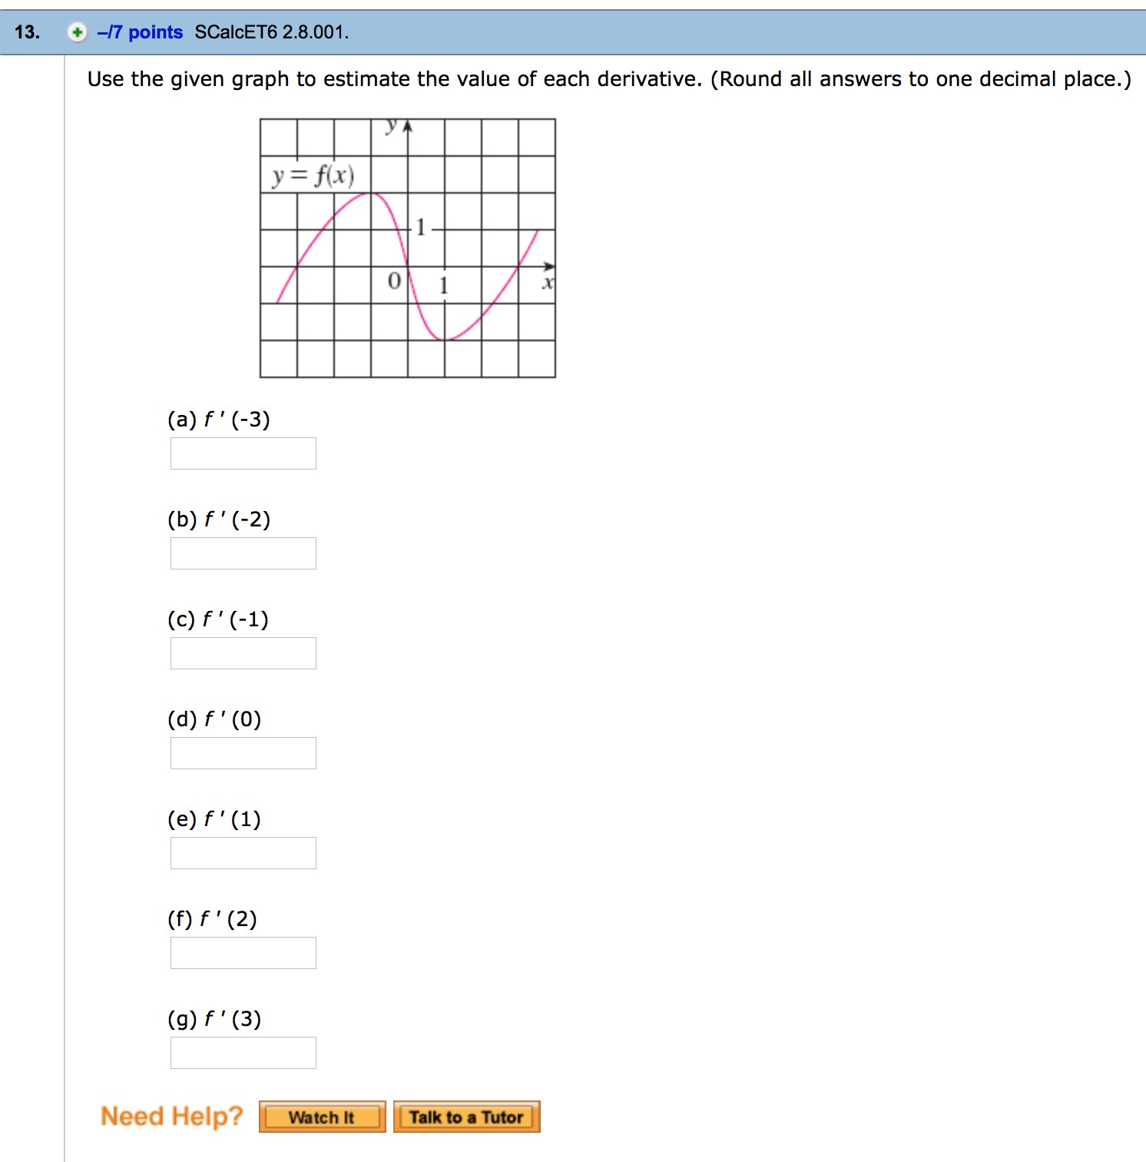
13(a)=2
13(b)=1
13(c)=0
13(d)=-1/2
13(e)=0
13(f)=-1
13(g)=1/2

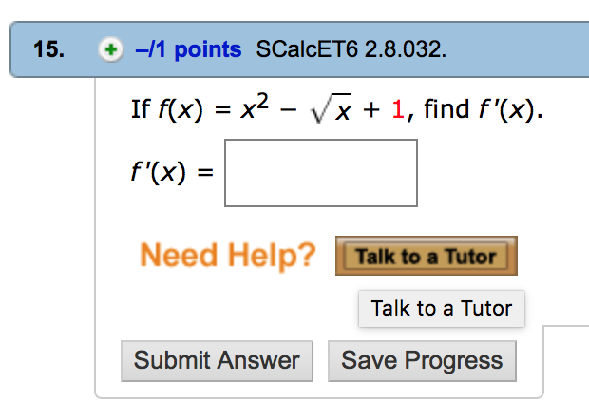
$\frac{∂y}{∂x}= 2x-\frac{1}{2√x}$

